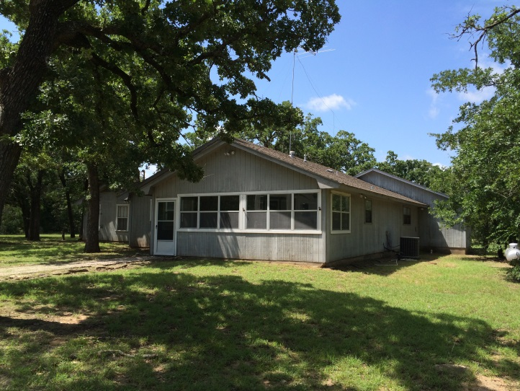
Game House

General Property Info.:

2 Parcels - 108.05 & 86 Acres = 194.050 Total Acres | No Active Leases
Taxes: $6,768.84 for 86 ACs & $3,352 for 108.05 ACs= $10,120.84 | 5 Tanks
1 Metal Workshop Bldg. | 5 BDRMs & 3 BAs
108.05 Parcel is not AG Exempted | Last Wing Built in 1996

Game House:

5th Wheel $34,000 | Built in 1986 | Only house that uses Propane
3,458sf of living space | Not sure of location – 29yr septic | 2 Outdoor CH/A units & 3 Indoor
Screened-In Porch | Security System | 3 Water Heaters with 1 on Propane
5 Bedrooms (3 on Wwing/2 on Swing) | Washer/Dryer Area – WWing Hallway | 3 Indoor CH Units w/1 on Propane
Master Suite Includes Hidden Nursery | 2 Indoor Breaker Boxes – FH & SWH | #2 Water Heater in Wwing Hallway
Septic is Traditional Lateral Lines | 1996/1987/2008 CH/A Units Installed

Kitchen:

Standing Propane Stove w/oven | Lots of Kitchen Cabinet Storage | Dishwasher
Disposal | Microwave | Bar Sink
Chopping Block Island

Game Room

3 Closets: 2 Large and 1 Small

Utilities:

Electricity: Navasota Valley Electric Co-op | Phone Company: Windstream
Water: City of Riesel | Propane: Star-Tex Propane
Trash: IESI

Provided By: Ruth Garrett
(254) 715-0135

Farm & Ranch Finders, LLC
10124 Saddle Creek Rd.
Waco TX 76708
(254) 836-1234

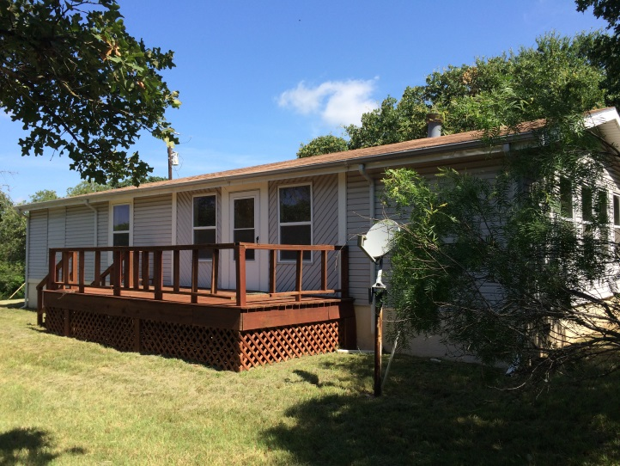
Mobile Home

General Property Info.:

Overlooks Pond | Front & Back Porches
Built in 1986 | 1,456sf of Living Space
1 Metal Workshop Bldg. on Slab | Fenced in Front Yard
Septic is Aerobic

Mobile Home Features:

Wood Burning Fireplace | 3 BDRMs & 2 BAs | Laundry Room
Security System | Covered Front Porch Decking | CH/A Located in Kitchen Closet
Water Heater Located in Laundry RM | All Electric | Partial Rain Gutters
Composite Roof is Same Age As Mobile | Septic Inspected: 5-28-15 | Septic Has Maintenance Contract
Metal Bldg. has 2 roll up doors

Kitchen:

Disposal | Pantry | Dishwasher
Electric Standing Stove | Refrigerator

Utilities:

Electricity: Navasota Valley Electric Co-op | Water: City of Riesel
Trash: IESI | Phone: Windstream

Provided By: Ruth Garrett
(254) 715-0135

Farm & Ranch Finders, LLC
10124 Saddle Creek Rd.
Waco TX 76708
(254) 836-1234
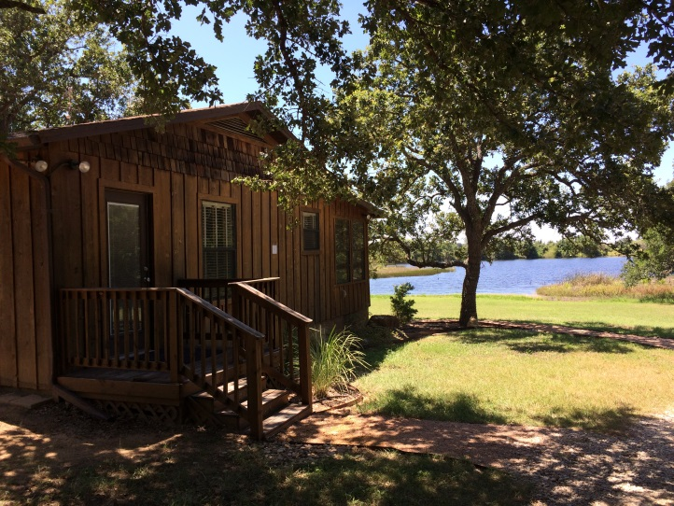
Cabin

General Property Info.:

Overlooks Pond | Fishing Pier
2 Morgan Bldgs. w/Electricity | 1 Office Bldg. w/Utilities
Manicured Lawn | Nestled in Matured Trees
Partial Rain Gutters

Cabin Features:

1 BDRM & 1 Bathroom | Covered Screened In Porch | Open Kitchen, Dining, Living Concept
1,005sf of Living Space | Built in 1978 | Pier & Beam
Traditional Septic w/Lateral Lines | 2 CH/A Installed in 2008 | 7yr. Roof
Septic Located 50ft SW of Cabin in Woods

Kitchen:

Dishwasher | No Disposal | Microwave
Electric Standing Range w/Oven | Deep Kitchen Sink | Bar
Office Nook | Trash Compactor (Needs Repair)

Utilities:

Electricity: Navasota Valley Electric Co-op | Phone Company: Windstream
Water: City of Riesel | Internet: Dish Network (Leasing Unit)
Trash: IESI

Provided By: Ruth Garrett
(254) 715-0135

Farm & Ranch Finders, LLC
10124 Saddle Creek Rd.
Waco TX 76708
(254) 836-1234
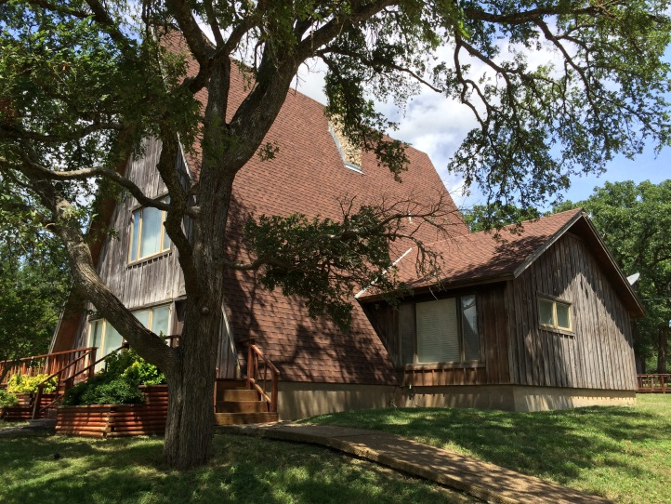
A-Frame House

General Property Info.:

2-Story Built in 1986 | 4 BDRMs & 3 BA’s
Overlooks Pond | Wood Decking Wrap-Around Porch

A-Frame House Features:

2,600sf of Living Space | Septic System: Aerobic System | 2 - A/C Units Installed in 2008
Security System | Septic Inspected: 5-28-15 | Septic Has Maintenance Contract
Underground Lawn Sprinkler | Water Softener | Composite Roofing - 1986
2 Bedrooms & 2 Bathrooms Downstairs | 2 Bedrooms & 1 BA Upstairs | Laundry Located in Hallway
Wood Burning Fireplace | 1 Water Heater/1 AC Unit Upstairs | 1 Water Heater/1 AC Unit Downstairs

Kitchen:

Dishwasher | Disposal | Microwave
Standing Range

Utilities:

Electricity: Navasota Valley Electric Co-op | Phone Company: Windstream
Water: City of Riesel | Propane: Star-Tex Propane
Trash: IESI

Provided By: Ruth Garrett
(254) 715-0135

Farm & Ranch Finders, LLC
10124 Saddle Creek Rd.
Waco TX 76708
(254) 836-1234

